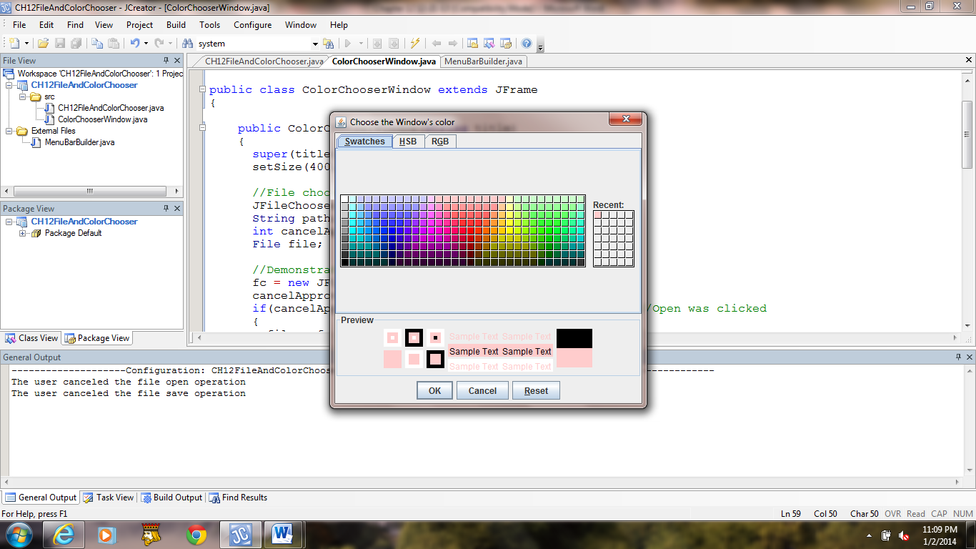 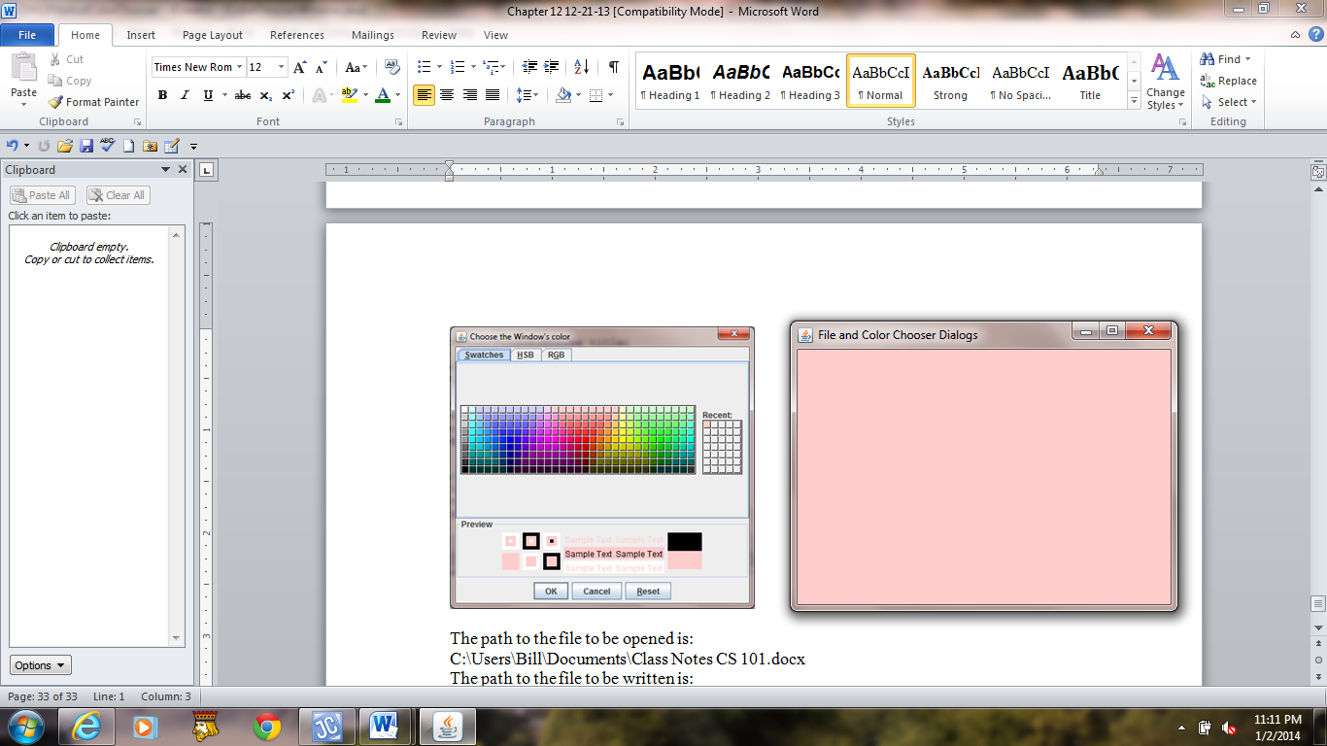

**a) b)**

**Figure 12.24 A JFileChooser dialog box and the ColorChooser application's program window.**